# CANOE Onboarding Activities

## Activity 1: Add industrial heat to the model

At the core of the CANOE model and energy system modeling as a whole is technologies. Technologies convert one commodity to another, whether it is a car converting gasoline to required passenger kilometers, or an electric arc furnace converting electricity into steel. This task is designed to make you comfortable with implementing new technologies into the model.

Currently, our test model has two regions, La Harmur and Moose Colonies. La Harmur has a demand for industry but only a technology for the electricity used to in industry, not the process heat needed. You need to create a technology for the process heat in industry for La Harmur based on the schematic below.

### Tasks

* Integrate industrial heat into La Harmur side of the model and ensure Moose Colonies still works.
* Ensure it follows breakdown shown in the figure above for all relevant tables.
* Once done, check that you have got everything correct.

### Hints (Some hints are free, for others change the colour of the font)

Hint 1: Assume the efficiency of the technology is 1, it makes the math easier as we don’t have an actual value for the output to go off. The investment cost is 1 M$/PJ and a fixed cost of 22 M$/PJ.

Hint 2: Remember that techinputsplit should be a percentage, i.e. 10% is 0.1, also that it cannot go above 100%/1 altogether.

Hint 3: If the model isn’t working, and everything else looks good, it is likely the technology table, the variable tag needs to be turned on (for the current version of the model).

## Activity 2: Working with Tech Groups

Something that has been added to the Temoa framework is the ability to group technologies into a group. It allows us to better control constraints related to groups rather than individual technologies. We can control new capacities, set max and minimum activities and more using technology groups.

The scenario for this activity: Both La Harmur and Moose Colonies have agreed to have a certain amount of renewables make up the electricity grid in each of the different time periods. This is similar to the Atlantic provinces where they have signed agreements to replace certain amounts of the electricity grid with renewable electricity sources.

### Tasks

* Create an appropriate group for this scenario
* Create the appropriate constraints for this renewable electricity scenario
* Once done, check that you have got everything correct and that the model runs

### Hints

Hint 1: The table you need to use is RPSRequirements

Hint 2: You can pick the appropriate technologies as you see fit, for the base test case we used hydro, wind and solar as renewable sources.

Hint 3: If the model isn’t working, remember that RPSRequirements is a percentage value.

## Activity 3: Debugging a model

While technologies and commodities are the core components of the CANOE model, debugging and ensuring the model runs correctly is a large component of our jobs as a collective. Creating new sections in the model is a surefire way of introducing new bugs and errors. It is our jobs to correct these before continuing onwards to analyze the data or before integrating it into the larger model.

In this scenario, in are given a model from your undergraduate student and they are confused why the model isn’t running. Being a good supervising student, you say you’ll investigate and try and get it working.

You didn’t realize there was so many errors…

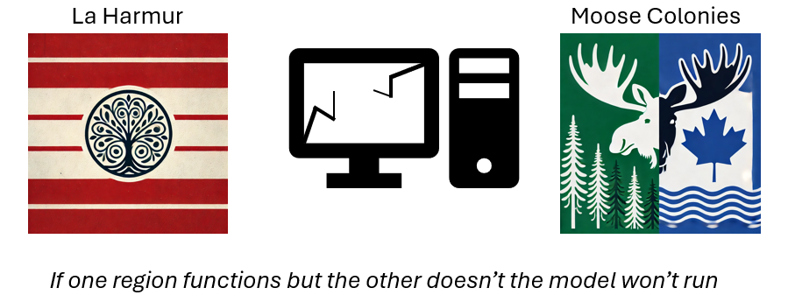

### Tasks

* (Optional) Check the tables that are the usual suspects
* Fix the model
* Run as many times as needed until it successfully runs (model is feasible)

### Hints

Hint 1: Check log file to see if there are certain issues

Hint 2: Two of the usual suspects include the efficiency and demand tables

Hint 3: Most common breakages in the model stem from the techinputsplit

Hint 4: Check constraints to make sure they are reasonable (i.e, restricting things to the point it can’t meet demand) (Check maxcapacitygroup and demand tables)

## Activity 4: Carbon Dioxide reducing technologies

There are only so many things that we can do to reduce carbon dioxide emissions, such as a higher amount of greener electricity and moving away from dirtier fuels. But at a certain point the model can’t get to zero emissions as some sectors use fossil fuels in every time period. One way to reduce carbon emissions is by using carbon capture technologies such as carbon capture and storage/utilization (CCU/S) and direct air capture (DAC).

La Harmur and Moose Colonies are putting certain limits on emission activities, 0 k Tonnes and 0 kTonnes respectively by 2035. To achieve this, the use of DAC is being implemented. Implement DAC into the model and constraint the emission activity to meet the provinces targets.

### Tasks

* Create the constraint for the emission target
* Create the technology for DAC with the correct information
* Test the model to ensure that it works

### Hints

Hint 1: Emission constraint will be inputted in the emissionlimit table

Hint 2: Need to create **demand** commodity for captured CO2

Hint 3: Need an emission activity linked to the capturing of CO2, likely being equal to the tech input split .

## Activity 5: Convert a mass/energy balance into a model

Most sectors in the model consist of technologies that have 1 or 2 inputs and 1 output. However, implementation of more complex systems might use multiple inputs and multiple outputs which can be difficult to conceptualize. In this activity, you need to convert the system below into a model. You will be provided a blank sqlite file with the correct tables and you need to fill it in with the information from the system below.

The model should have 4 technologies and 7 commodities. It is up to you to calculate the efficiency, techinputsplit and techoutputsplit. The variable cost for A and B should be assumed as 1. If you are correct with your model, there should be no errors or infeasibilities.

### Tasks

* Calculate the efficiency, techinputsplit and techoutput split.
* Create the model using the numbers you calculated.

### Hints

Hint 1: The equation for efficiency is out/in.

Hint 2: The equation for techinputsplit and techoutputsplit is variable/sum of variables

Hint 3: The efficiency for import and FINAL should be 1